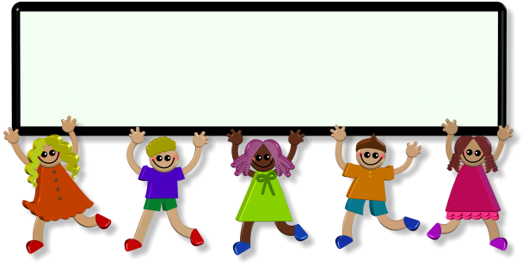
K-2 Sample Schedule for Home Learning

8:00- 9:00am | Wake up (keep to regular sleep schedule) | Eat breakfast, get dressed, morning prayer
9:00- 10:00am | Physical activity | Play, morning walk, outside play, kids yoga
10:00- 10:15am | Snack time | Nutrition break, wash your hands
10:15- 11:00am | Academic time | Check-in with Google Classroom, activities the teacher has sent out.
11:00 - 12:00 | Creative time | Lego, drawing, colouring, crafting, listening to music, cook/bake, sing, etc.
12:00 | Lunch | Prayer before meals, wash your hands
12:30-1:00 | Chore time | Help clean up lunch, make your bed, clean up toys
1:00- 2:00 | Quiet time | Read a book, puzzles, play a board game, counting collections, money play, free writing
2:00 - 2:15 | Snack time | Nutrition break
2:15-3:00 | Academic time | Check-in with Google Classroom, activities the teacher has sent out.
3:00 - 3:30 | Physical activity | Play, morning walk, outside play, kids yoga

